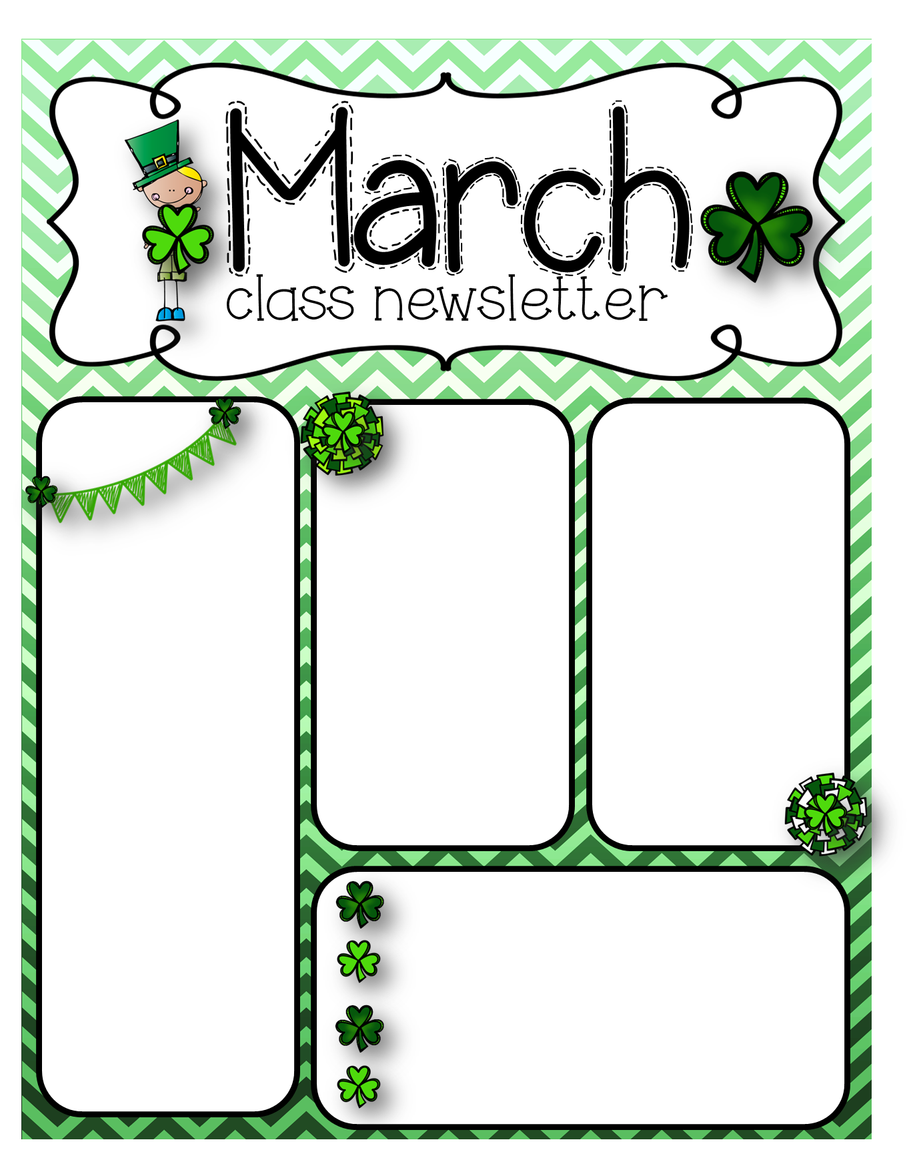

We finished learning about weight and comparing if objects are lighter, heavier, or heavy as.

We worked on er words in class.

We started a weather unit this week. We listened to WDTN weather’s forecast and collected data from it to fill in our weather journals. We learned about types of weather, a few instruments, and how to dress in certain types of weather. We also talked about the seasons and what kind of weather is in each season.

Zoo field trip is scheduled for May 20. You must have finger prints done to attend.

**Theme**

Weather

**Snap List Words**

set put here

another ask

**March**

**9 –** Red and White Auction

**13 –** No school – teacher in-service

**18 –** Early dismissal – 1:15

**21 – 29** – Spring Break

**30 –** school resumes

**Spelling**

1. sir
2. fir
3. dirt
4. girl
5. stir
6. first
7. third
8. birthday
9. any
10. take